**SUMMARY**

CONTROL OF REVISIONS ……………………………………………………………………………….2

OVERVIEW ………………………………………………………………………………………………….2

**PROCESS VOLUME …………………………………………………………………………………….2**

**OPERATION PREMISES ……………………………………………………………………………….2**

**TARGET SYSTEM ……………………………………………………………………………………….3**

**SYSTEMS CREDENTIALS ……………………………………………………………………………..4**

PROCESS DIAGRAMS …………………………………………………………………………………...5

PROCESS DETAILS ……………………………………………………………………………………….6

BUSINESS RESTRICTION ………………………………………………………………………………..20

BUSINESS EXCLUSION …………………………………………………………………………………..20

# CONTROL OF REVISIONS

|  |  |  |  |
| --- | --- | --- | --- |
| ***Version*** | ***Date Issued*** | ***Description*** | ***Author*** |
| *1.0* | *30/06* | *Initial Document* | *Maria Delmonaco* |
| *2.0* | *04/07* | *Android Updated* | *Maria Delmonaco* |

# OVERVIEW

The process automates the inspection workflow in electrical substations. Technicians now use a mobile Android app which operates offline, to fill out digital checklists. The collected data is stored locally and later processed by a Python robot that generates PDF reports, updates Excel records, and can send email alerts in case of detected failures. This approach eliminates manual rework, improves operational visibility, and supports disconnected environments.

## PROCESS VOLUME

|  |  |
| --- | --- |
| **Description** | **Value** |
| Volume / Year | 365 |
| Manual Handling Time (min) | 40 min/inspection |
| Exception Level | High |

## OPERATION PREMISES

**Execution Time:** Every day at 10:00 AM, can be manually executed if there are any critical situations that need to be handled out of the ordinary execution time.

**Execution Days:** Inspections are conducted **7 days a week**, especially in high-demand areas or critical infrastructure zones.

**Average Duration:** The estimated time to complete one inspection is **20 min**

**Devices:** Android 9.0+, Windows 10+, Linux, macOs

**Technologies:** Python 3.10+, Streamlit, Pandas, OpenPyXl, FPDF, PyPDF2, FastAPI, PostgreSQL, Android Studio

**Offline Mode:** Fully supported with local file/database persistence

## TARGET SYSTEM

|  |  |  |
| --- | --- | --- |
| **System** | **Description** | **Version** |
| Local Android Device | Runs the standalone mobile app with offline checklists input | Android 9.0+ |
| Python Runtime | Executes the Python application | Python 3.10+ |
| Pandas Library | Processes inspection data in-memory and exports to Excel | Latest (e.g., 2.x) |
| OpenPyXL Library | Used for writing and appending. files for inspection data.xlsx | Latest (check via import openpyxl; print(openpyxl.__version__)) |
| FPDF/PyPDF2 | Used to generate PDF reports of the checklist. | 1.7.2 or latest |
| PostgreSQL | Stores persistent checklist data | PostgreSQL 14+ |
| SQLAlchemy | ORM for database connection | Latest |
| Stremlit | Fronted framework for web interface | Latest |
| FastAPI | Backend API handling and services | Latest |
| Uvicorn | ASGI server to run FastAPI | Standard |
| Android Studio | Development environment for building the Android app prototype | Latest |

## 

## SYSTEMS CREDENTIALS

|  |  |
| --- | --- |
| **System** | **Credential** |
| Local File System | Not required |
| PostgreSQL | Required (env vars) |
| Python Runtime | Not required |
| Mobile GUI | Not required |

# PROCESS DIAGRAMS

AS-IS Process (Current Manual Process):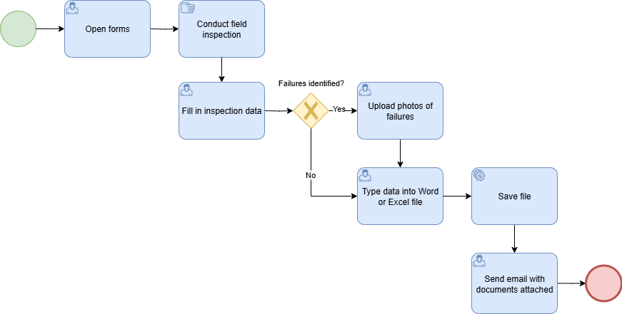

TO-BE Process (New Digital Process):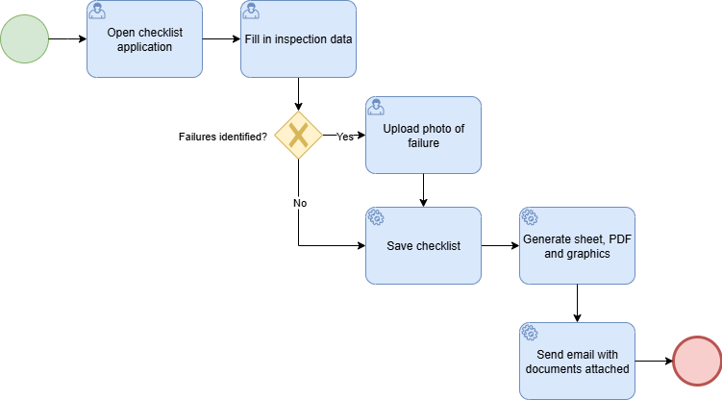

# PROCESS DETAILS

**Open browser and enter the checklist link:**

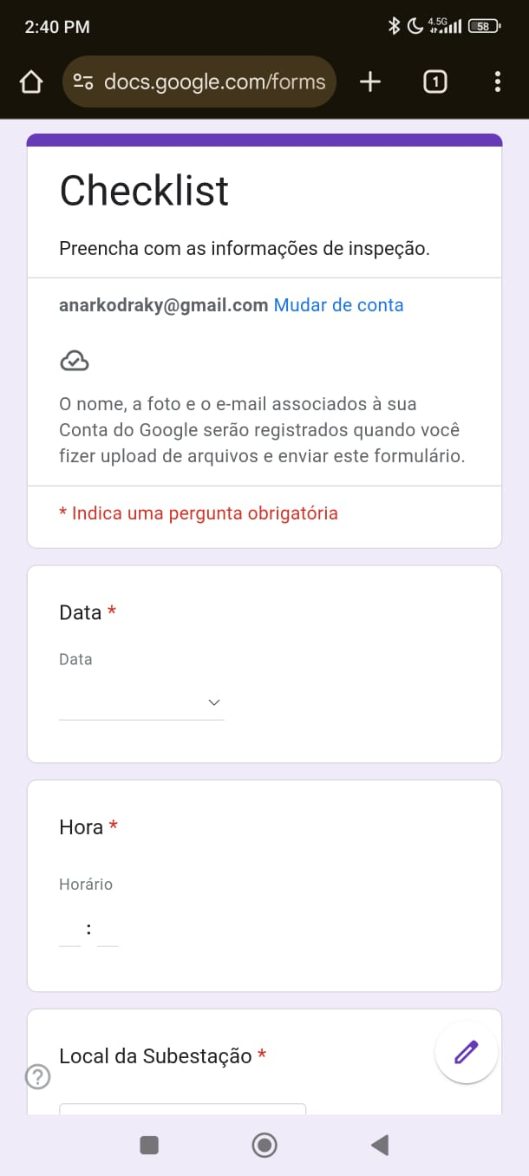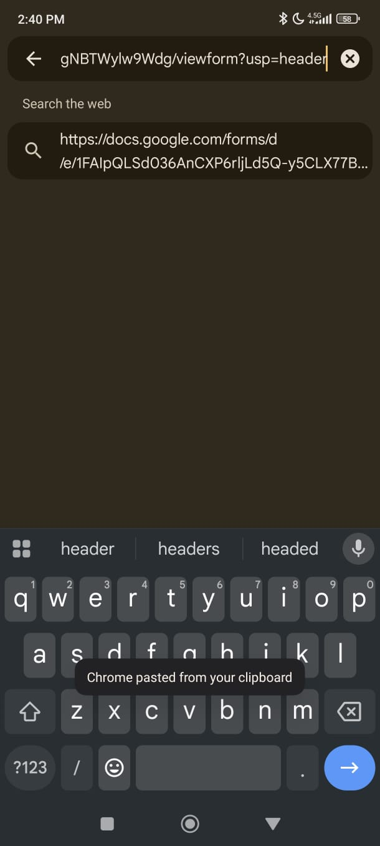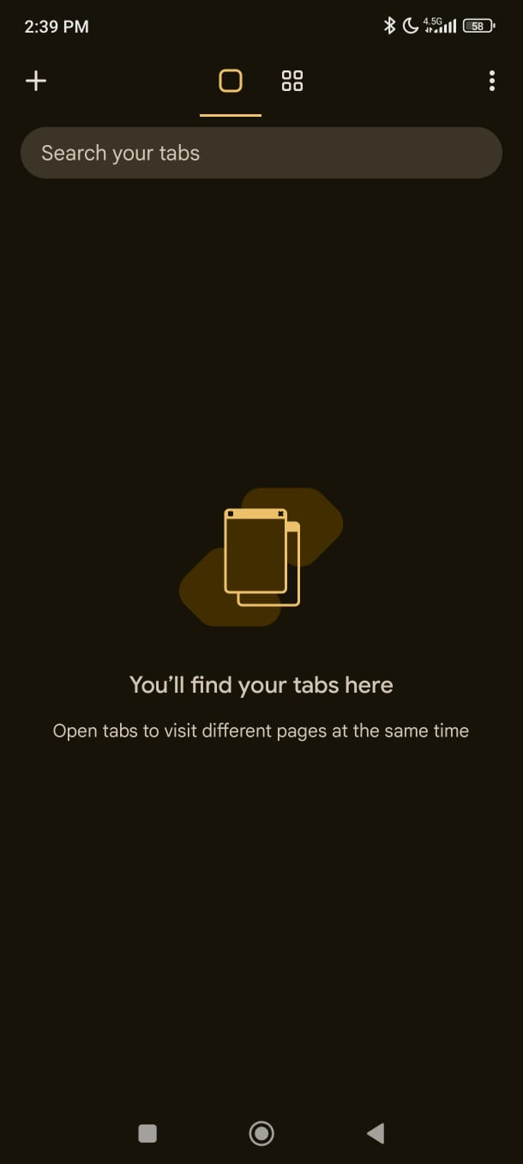

**Filling Date and Time:**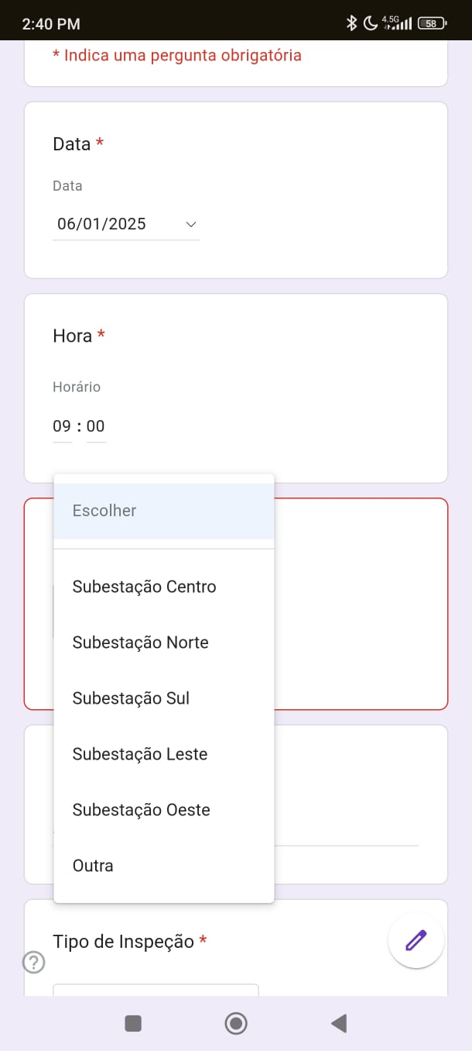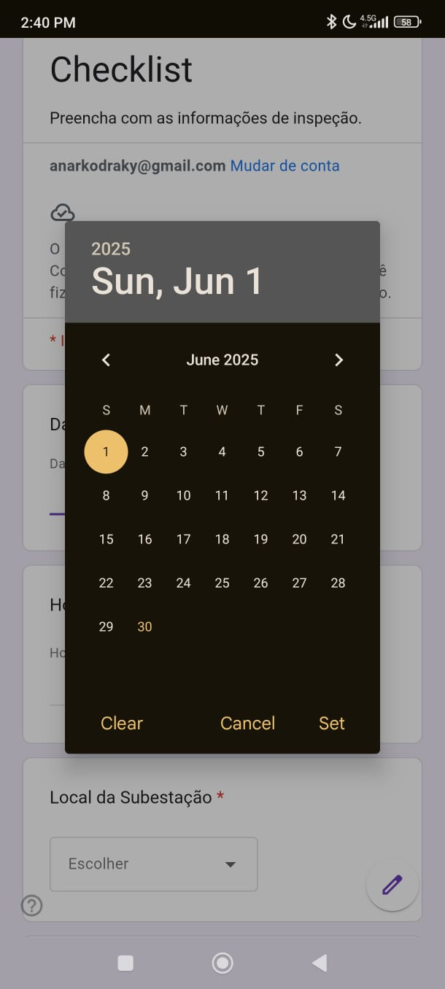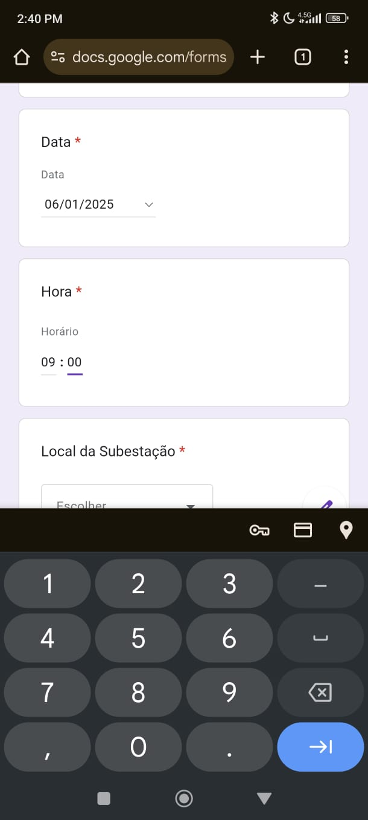

**Filling forms:**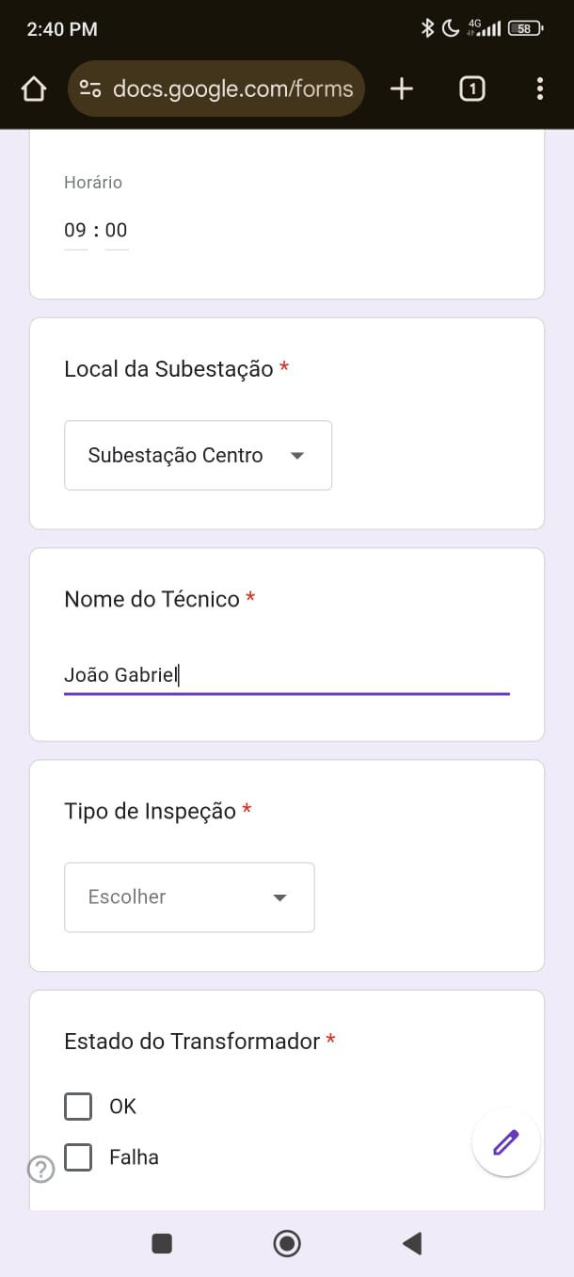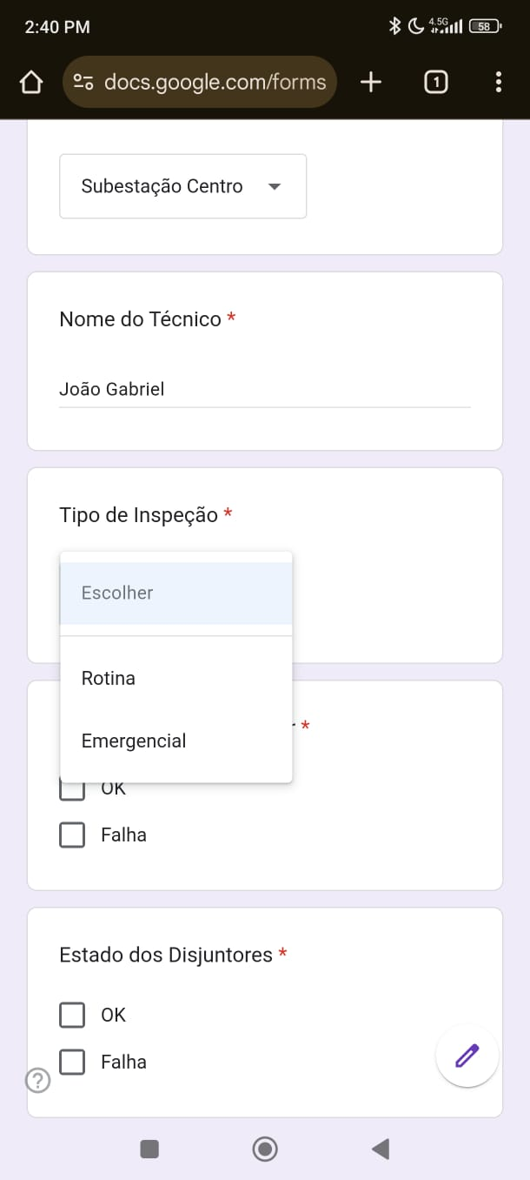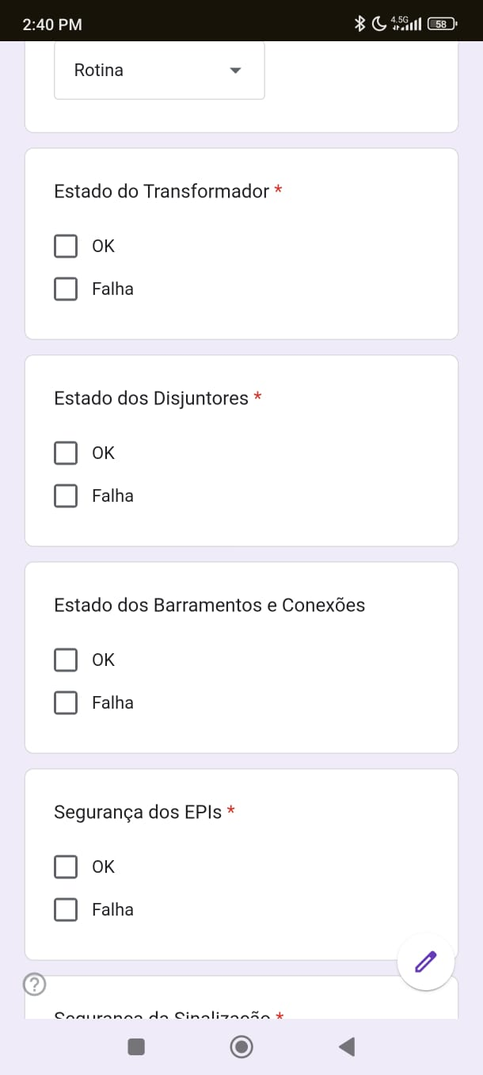

**Checking Equipment and Security:**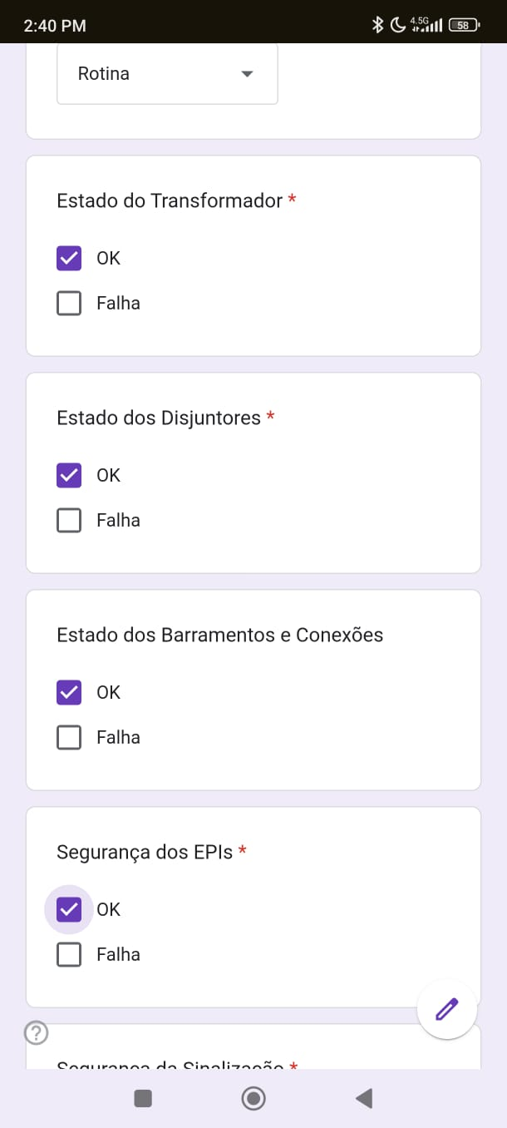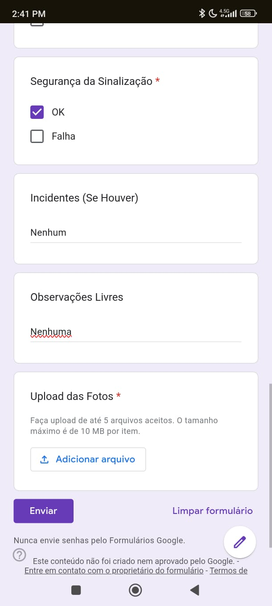

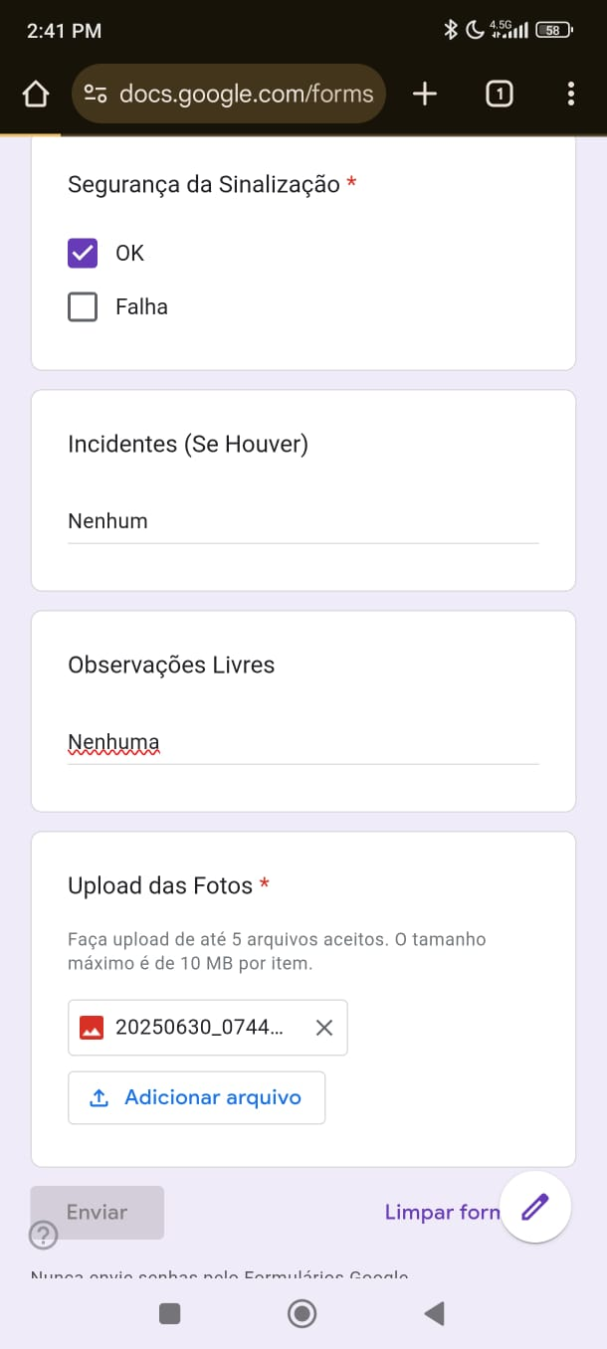

**Forms sent:**

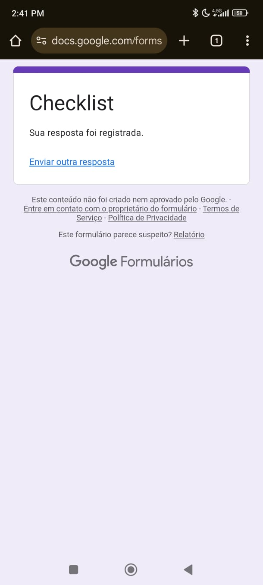

**Data received from forms:**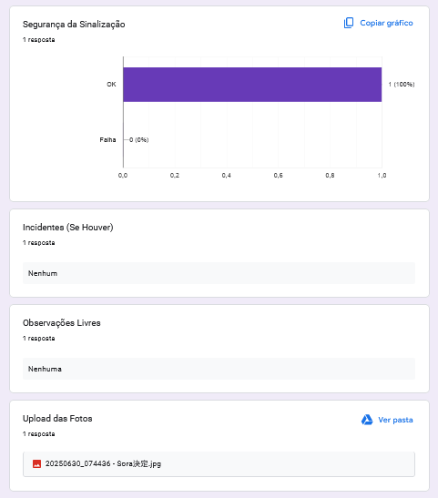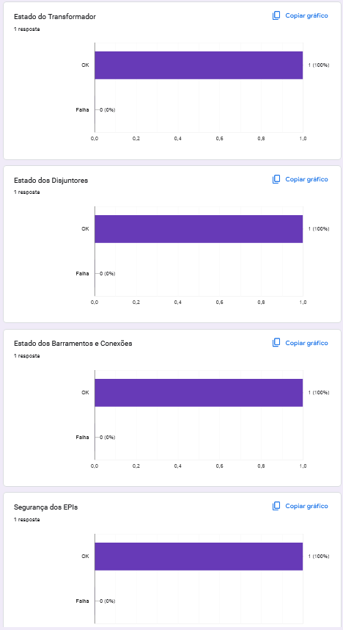

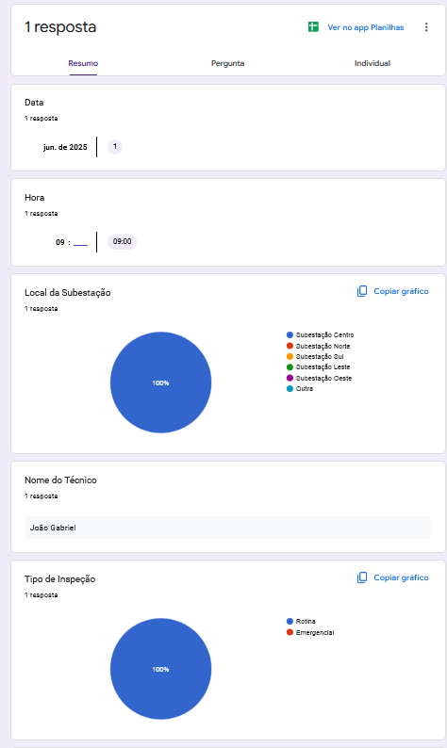

**Sheet filled on Excel:**

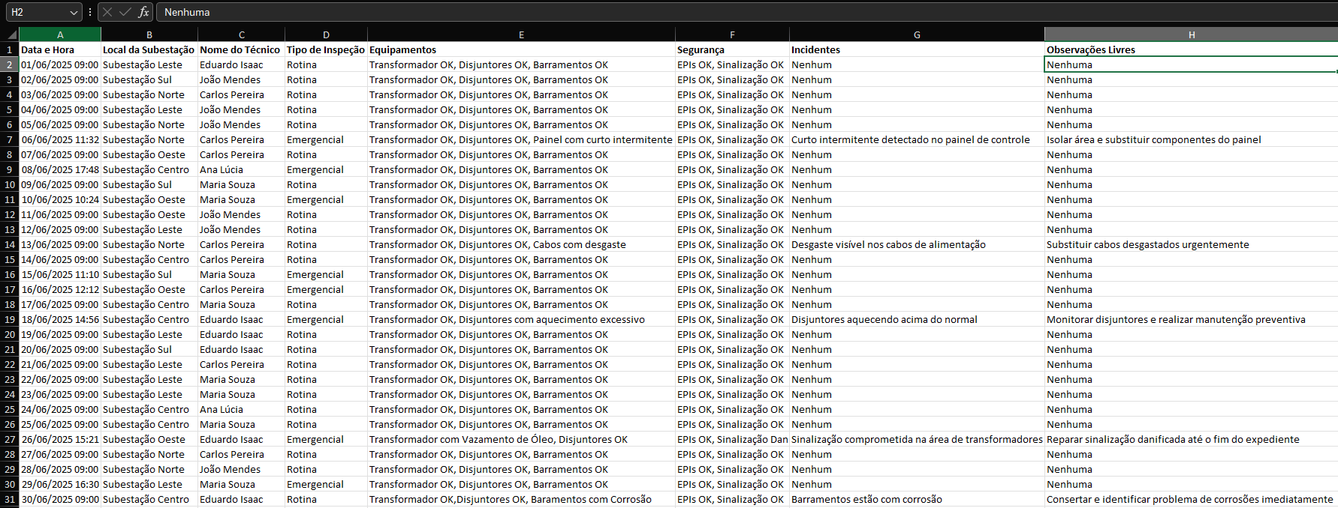

**Save xslx file:**

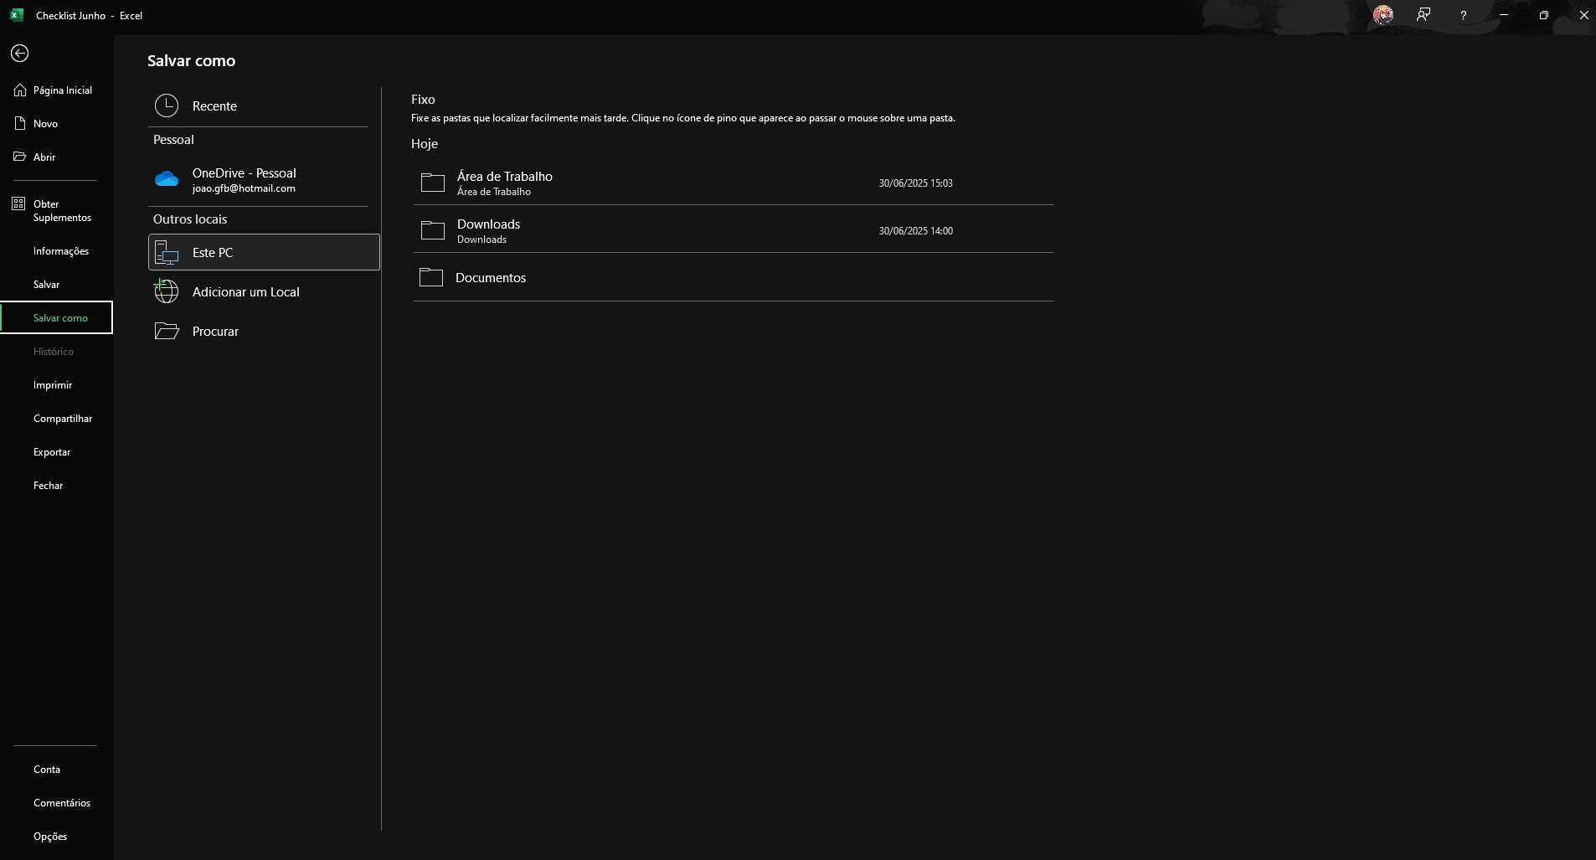

**Open browser:**

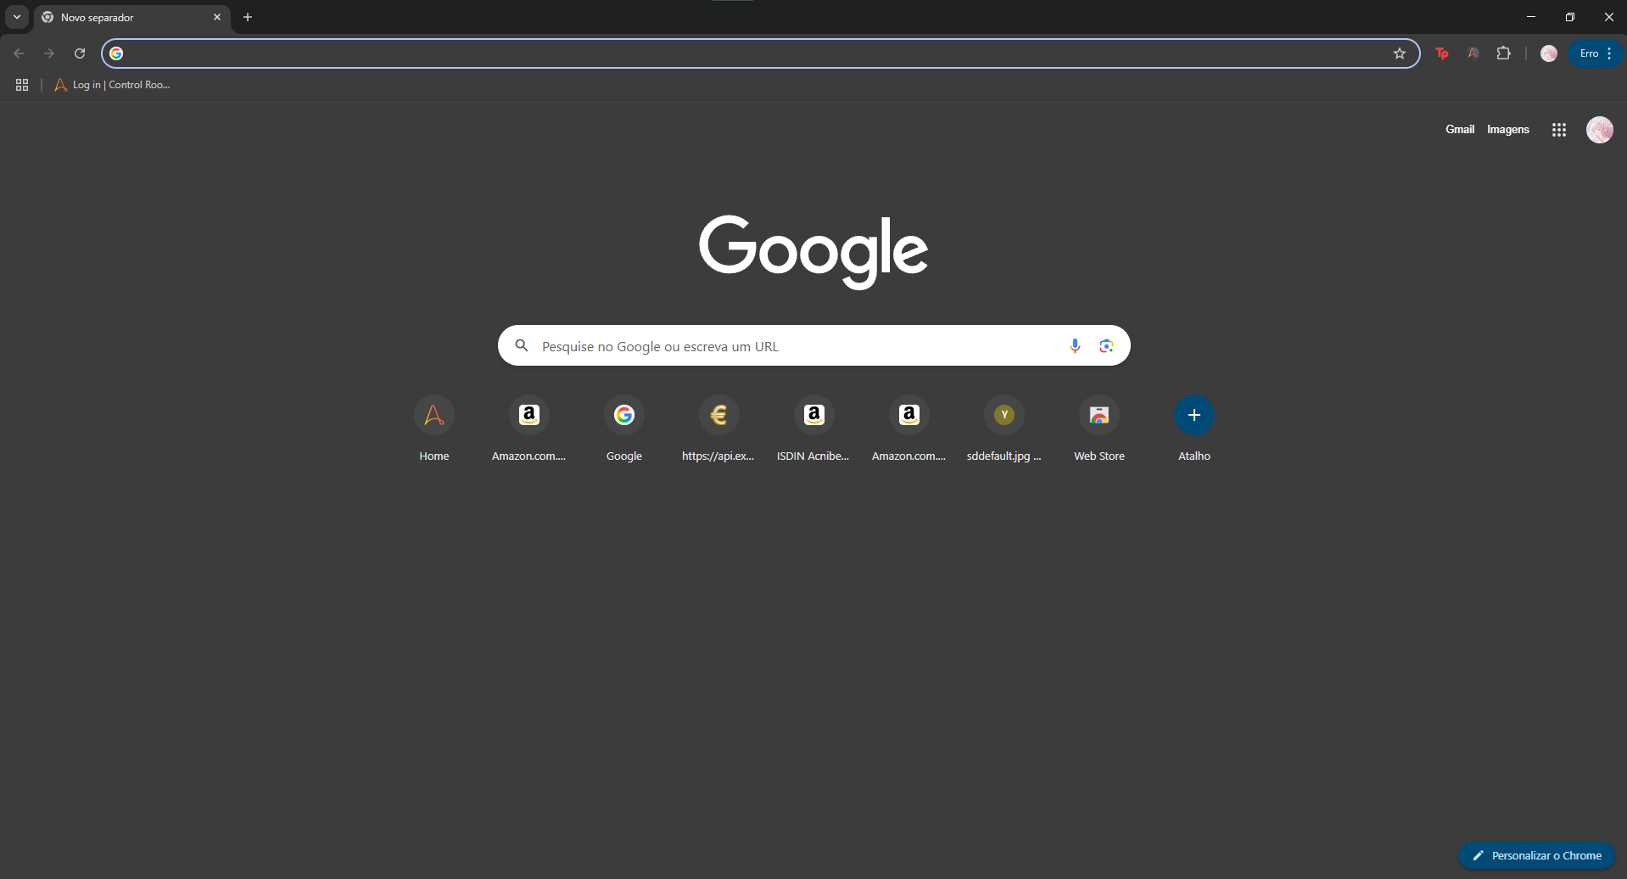

**Search “Gmail”:**

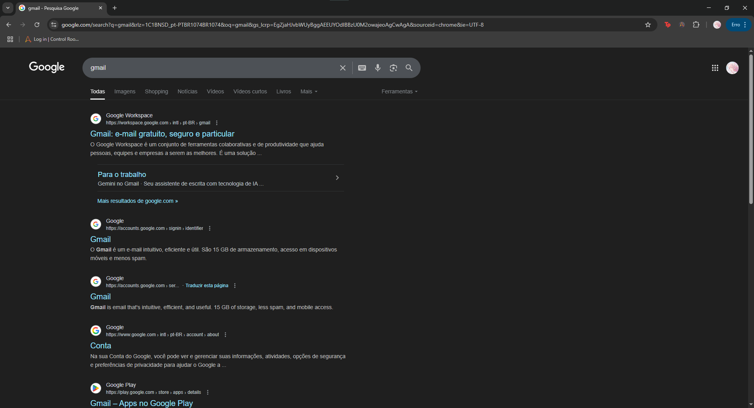

**Open Gmail:**

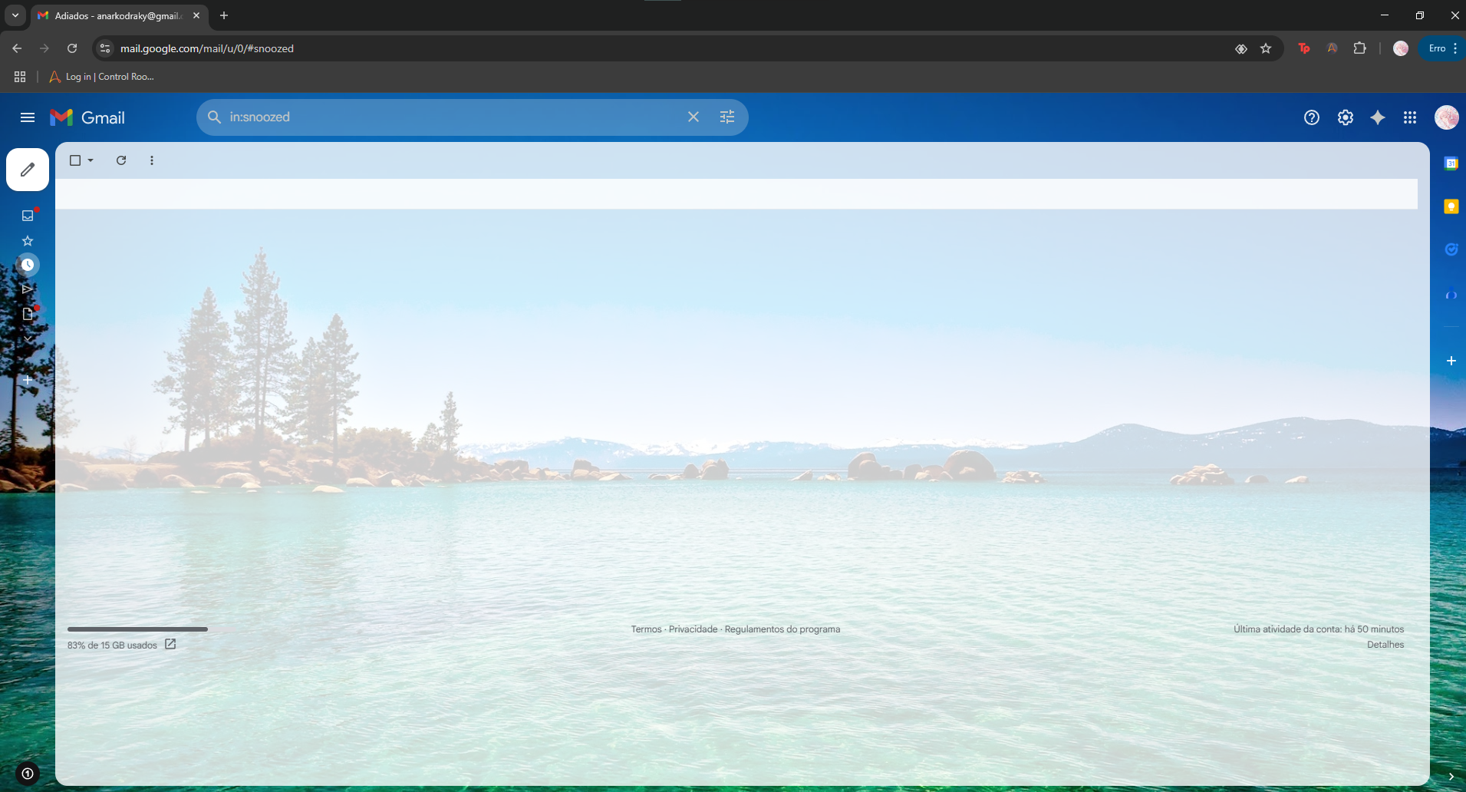

**Send a new mail:**

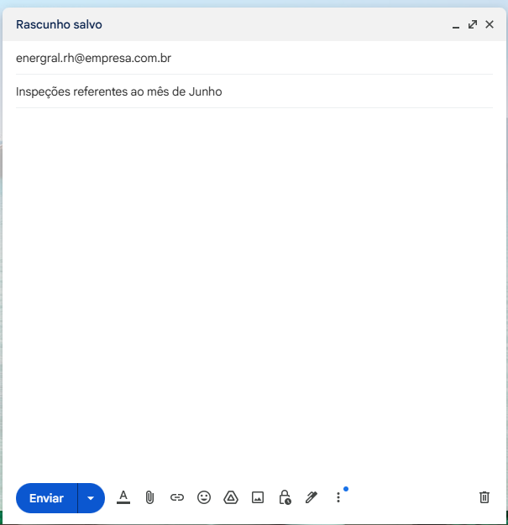

**Attach the xlsx file:**

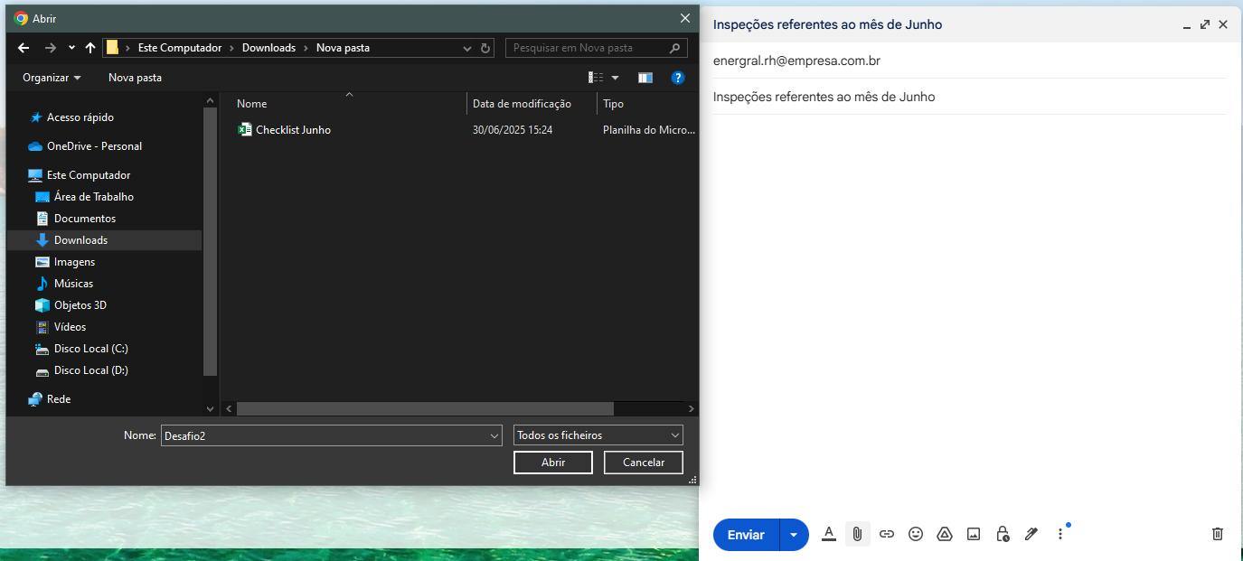

**Send mail:**

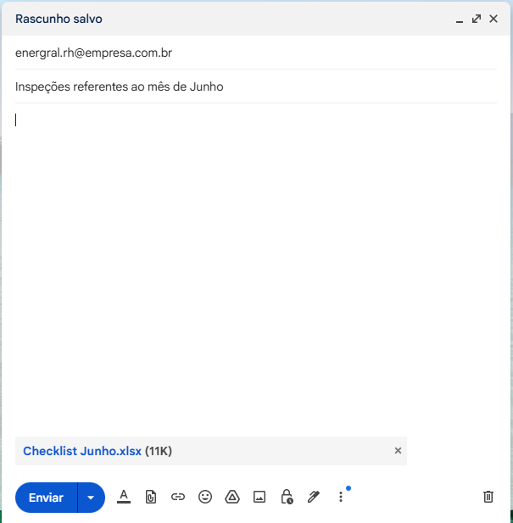

**Mail sent:**

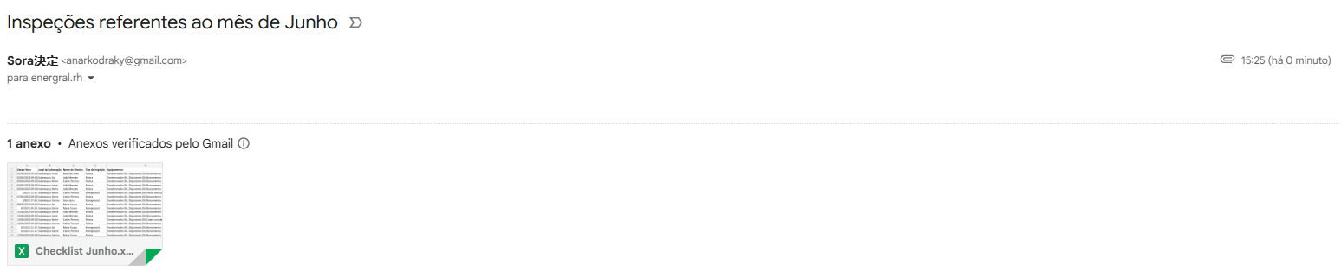

# BUSINESS RESTRICTION

**Offline Operation:** No internet required for field inspections;

**PostgreSQL:** used for persistent strorage;

**Compatibility:** Android 9+/Windows/Linux/macOS Python 3.10+

**Execution:** Daily at 10:00 AM or manually triggered

# BUSINESS EXCLUSION

**No Cloud Sync:** Real-time (manual sync when online);

**Mobile-only:** For field input; desktop use limited to supervision/report

**Email:** Functionality is optional and dependent on internet

**Language:** Portuguese-only Ui (English optional)